**DATA QUALITY REPORT**

**BY**

**SUMEET G DUDDAGI**

1. **HIGH LEVEL DESCRIPTION**

The given data is a 2010/2011 dataset of New York Property valuation and assessment

to analyze the possible property tax going on in the city. It consists of 1,070,994 records and 32 columns.

Information about can be found here <https://data.cityofnewyork.us/Housing-Development/Property-Valuation-and-Assessment-Data/rgy2-tti8>.

Dataset Name: Property Valuation and Assessment Data.

Dataset Description : Property Valuation and Assessment Data

Dataset Category: Housing and Development.

Dataset Owner: NYC OpenData.

Agency Name: Department of Finance (DOF).

Date Created: September 2, 2011

Update frequency: Annually

Columns: RECORD, BBLE, BORO, BLOCK, LOT, EASEMENT, OWNER, BLDGCL,

TAXCLAS, LTFRONT, LTDEPTH, EXT, STORIES, FULLVAL, AVLAND, AVTOT,

EXLAND, EXTOT, EXCD1, STADDR, ZIP, EXMPTCL, BLDFRONT, BLDDEPTH,

AVLAND2, AVTOT2, EXLAND2, EXTOT2, EXCD2, PERIOD, YEAR, VALTYPE.

1. **TWO FIELD SUMMARY TABLES**

**A. NUMERICAL COLUMN FIELDS**

|  |  |  |  |  |  |  |
| --- | --- | --- | --- | --- | --- | --- |
| **Field Name** | **% Populated** | **Min** | **Max** | **Mean** | **Stdev** | **% zero** |
| **LTFRONT** | 100 | 0 | 9999 | 36.64 | 74.03 | 15.79 |
| **LTDEPTH** | 100 | 0 | 9999 | 88.86 | 76.40 | 15.89 |
| **STORIES** | 94.75 | 1 | 119 | 5.01 | 8.37 | 0 |
| **FULLVAL** | 100 | 0 | 6,150,000,000 | 874,264.51 | 11,582430.99 | 1.21 |
| **AVLAND** | 100 | 0 | 2,668,500,000 | 85,067.92 | 4,057,260.06 | 1.21 |
| **AVLAND2** | 26.40 | 3 | 2,371,005,000 | 246,235.72 | 6,178,962.56 | 0 |
| **AVTOT** | 100 | 0 | 4,668,309,000 | 227,238.17 | 6,877,528.31 | 1.21 |
| **EXLAND** | 100 | 0 | 2,668,500,000 | 36,423.89 | 3,981,575.79 | 45.91 |
| **YEAR** | 100 | 2010 | 2011 | - | - | - |
| **EXTOT** | 100 | 0 | 4,668,309,000 | 91,186.98 | 6,508,402.82 | 40.39 |
| **BLDFRONT** | 100 | 35.38 | 7575 | 23.04 | 35.58 | 21.36 |
| **BLDDEPTH** | 100 | 42.71 | 9393 | 39.92 | 42.71 | 21.37 |
| **AVTOT2** | 26.40 | 3 | 4,501,180,000 | 713911.44 | 11652528.95 | 0 |
| **EXLAND2** | 8.17 | 1 | 2,371,005,000 | 351,235.68 | 10802212.67 | 0 |
| **EXTOT2** | 12.22 | 7 | 4,501,180,000 | 16072510.17 | 16072510.17 | 0 |

**B. CATEGORICAL FIELDS**

|  |  |  |  |
| --- | --- | --- | --- |
| **Field Name** | **% Populated** | **# Unique Values** | **Most Common Value** |
| **RECORD** | 100 | 1070994 | - |
| **BBLE** | 100 | 1070994 | - |
| **BORO** | 100 | 5 | 4 |
| **Block** | 100 | 13984 | 3944 |
| **LOT** | 100 | 6366 | 1 |
| **EASEMENT** | 0.43 | 12 | E |
| **OWNER** | 97.04 | 863347 | PARKCHESTER PRESERVAT |
| **BLDGCL** | 100 | 200 | R4 |
| **TAXCLASS** | 100 | 11 | 1 |
| **EXT** | 66.92 | 3 | G |
| **STADDR** | 99.94 | 839280 | 501 SURF AVENUE. |
| **ZIP** | 97.20 | 196 | 10314.0 |
| **EXMPTCL** | 1.45 | 14 | X1 |
| **PERIOD** | 100 | 1 | FINAL |
| **VALTYPE** | 100 | 1 | AC-TR |
| **EXCD1** | 59.62 | 129 | 1017 |
| **EXCD2** | 8.68 | 60 | 1017 |

**3. FIELD DESCRIPTIONS**

RECORD

Column Description: This gives a serial number or a unique number for each property value of NY in an ascending order. This field value is unique to each row.

Type: Categorical

BBLE

Column Description: This gives a unique number for each property value of NY in an ascending order. This field value has no missing value and is unique to each row

Type: Categorical

BORO

**Column Description**: Borough.

1 = Manhattan

2 = Bronx

3 = Brooklyn

4 = Queens

5 = Staten Island

**Type:** Categorical

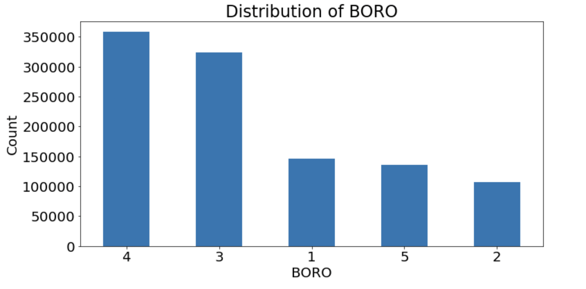

BLOCK

Column Description: Valid Block ranges by BORO.

Manhattan: 1 to 2255

Bronx: 2260 to 5958

Brooklyn: 1 to 8955

Queens: 1 to 16350

Staten Island: 1 to 8050

Type: Categorical

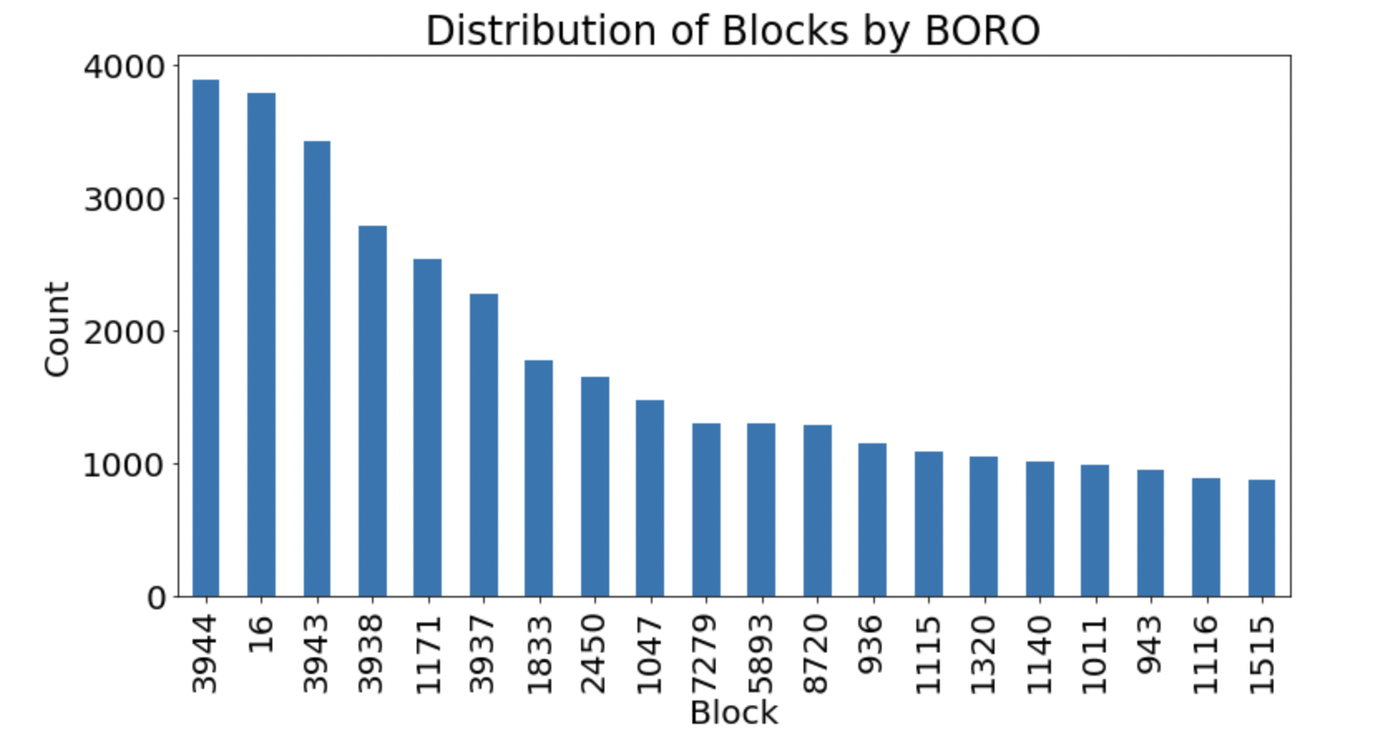

LOT

Column Description: Unique within Block/BORO.

Type: Catogorical

No. of Unique Entries: 6366

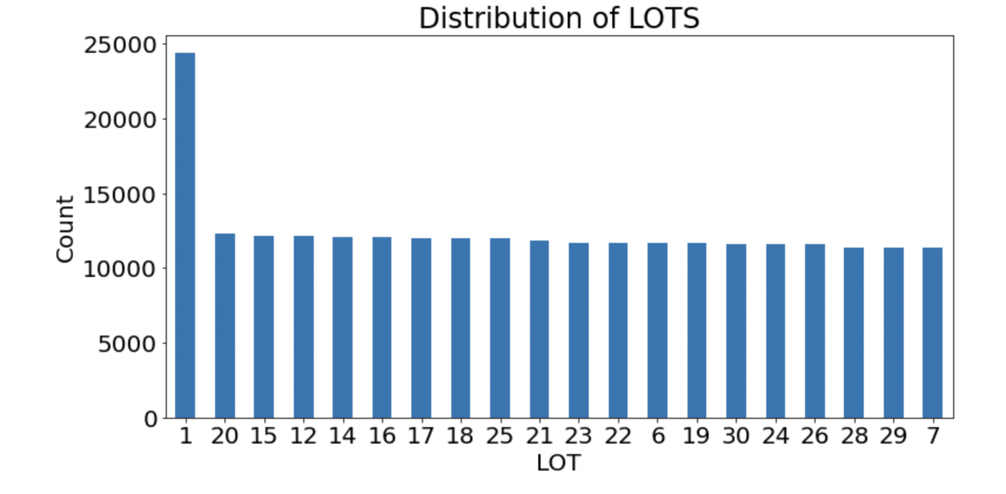

EASEMENT

Column Description: column which describes easement.

Type: Categorical.

Space = No Easement

A = Air Easement

B = Non-Air Rights

E = Land Easement

F Thru M are duplicates of E

N = Non-Transit Easement

P = Pier

R = Railroad

S = Street

U = U.S. Government

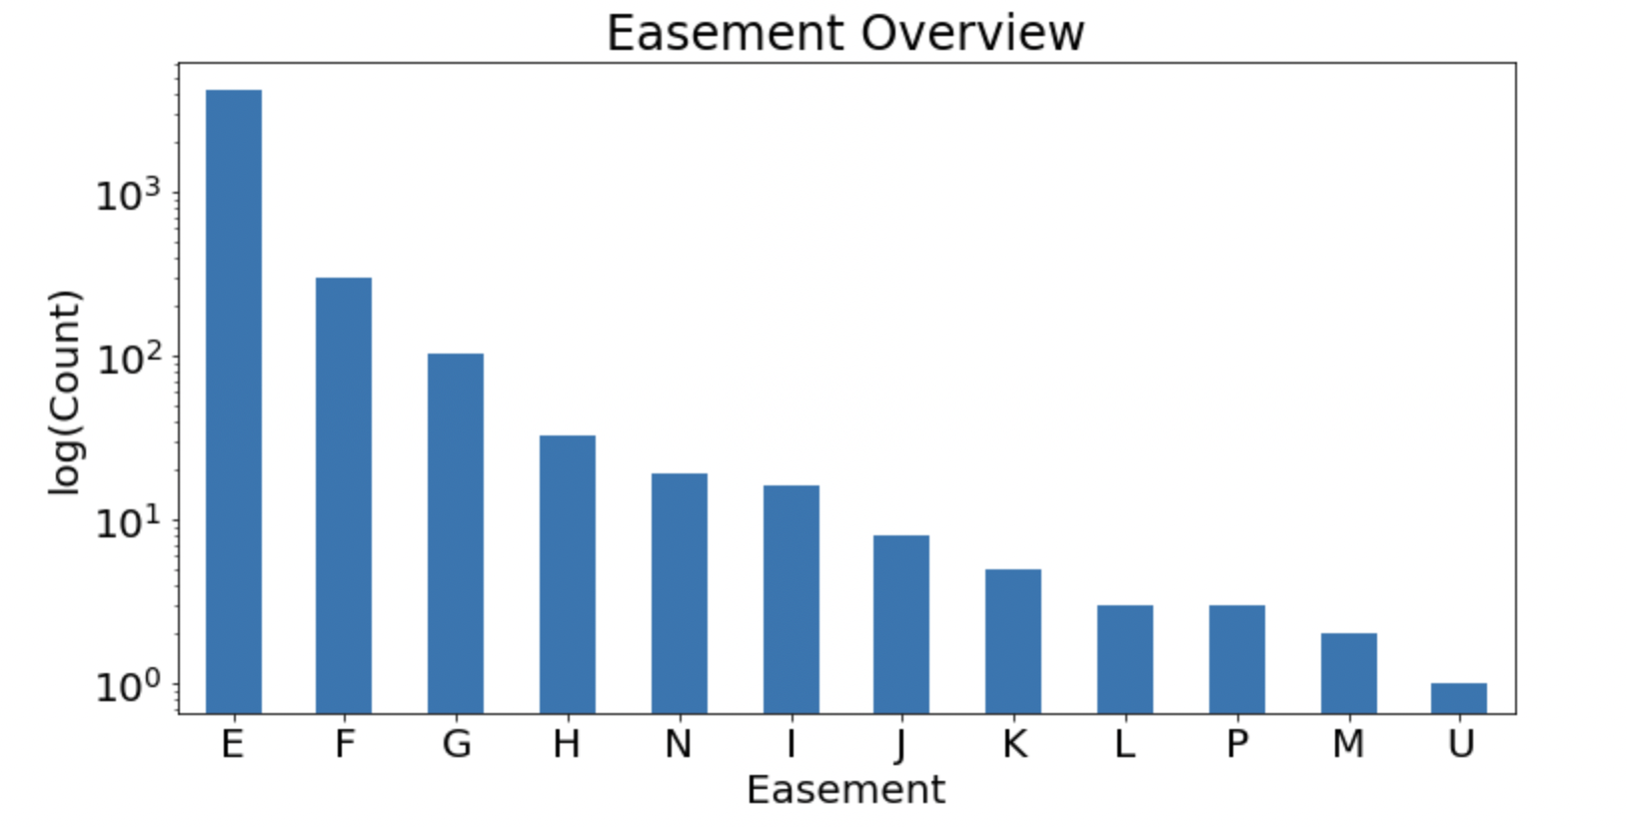

OWNER

Column Description: It gives the names of a owner for a property value.

Type: Categorical

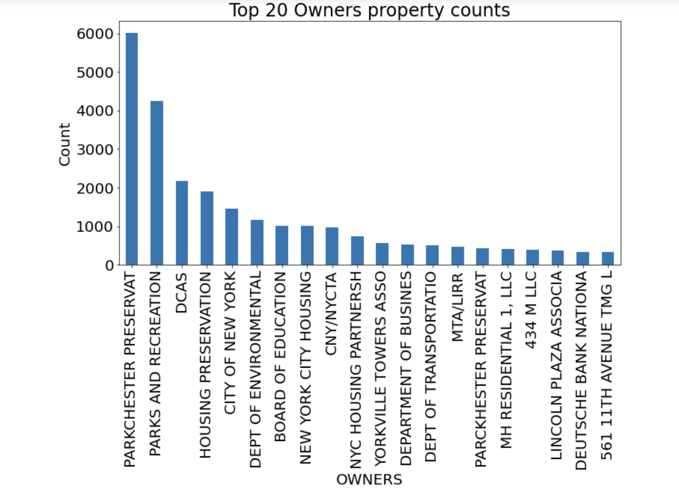

BLDGCL

Description: Provides a building class for a property

Type: Categorical

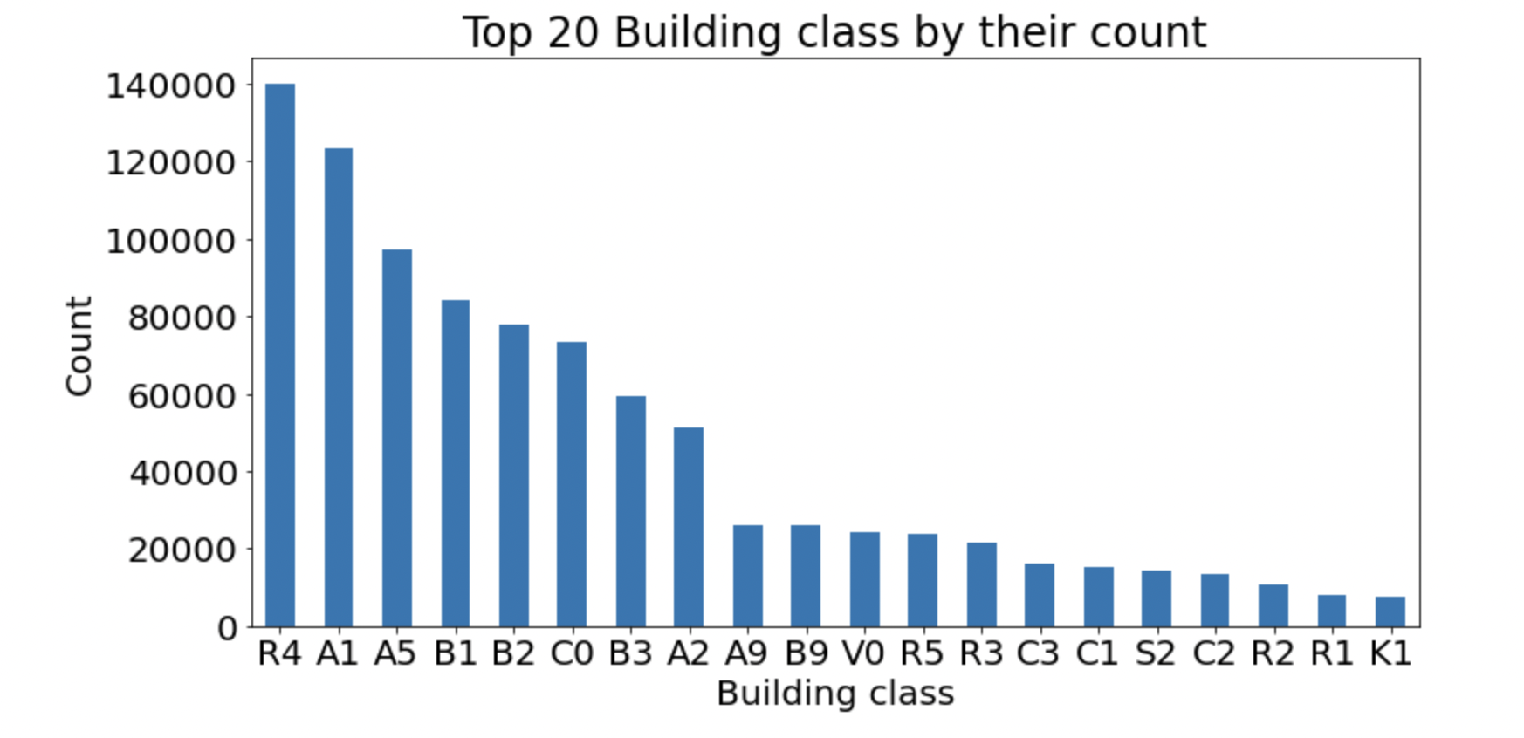

TAXCLASS

Column Description: Divides the properties based on various tax classes.

Type: Categorical

1 = 1 - 3 Unit Residence

2 = Apartments, 2A = 4, 5, or 6 Units

3 = Utilities

4 = All Others

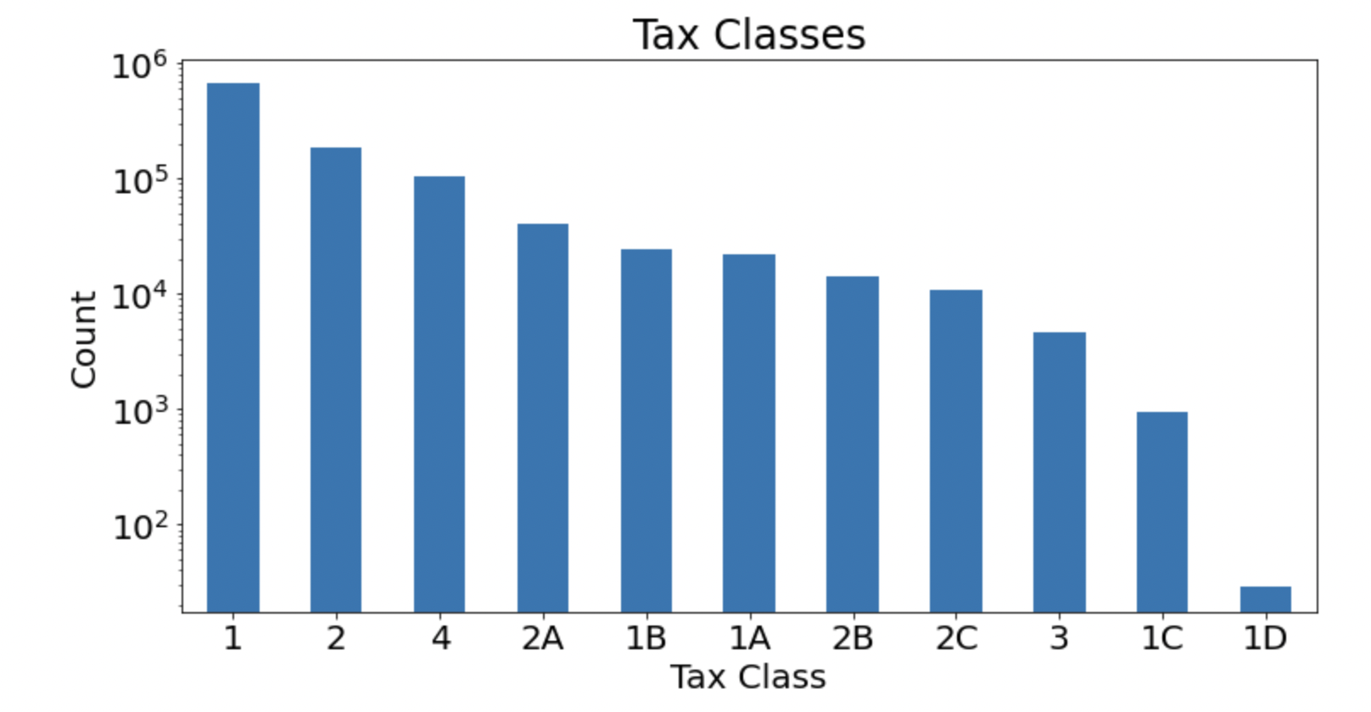

LFTRONT

Column Description: Lot Width

Type: Numerical

Note: the “0” entries are probably missing values

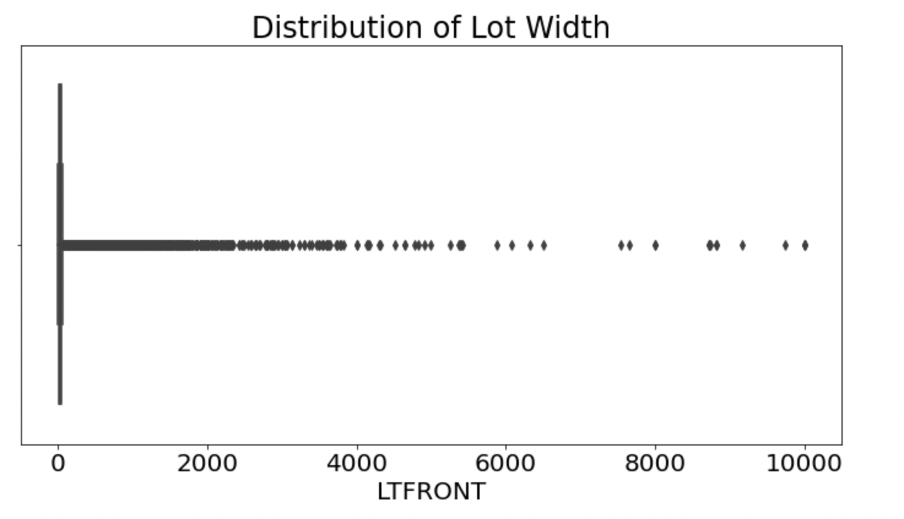

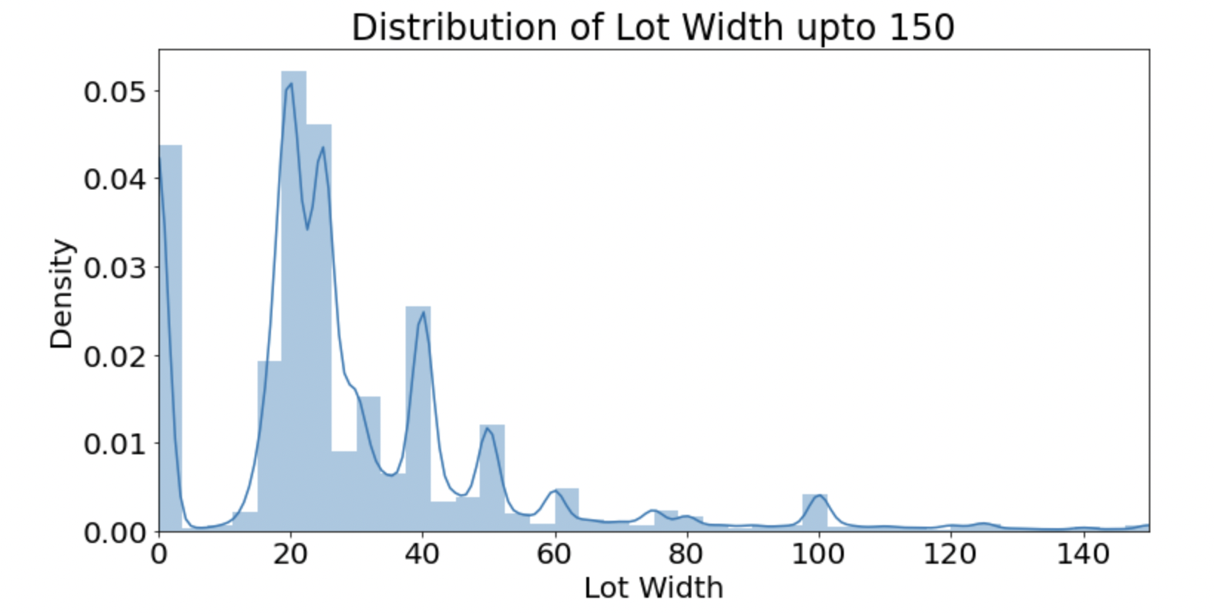

LTDEPTH

Column Description: Lot Depth

Type: Numerical

Note: the “0” entries are probably missing values

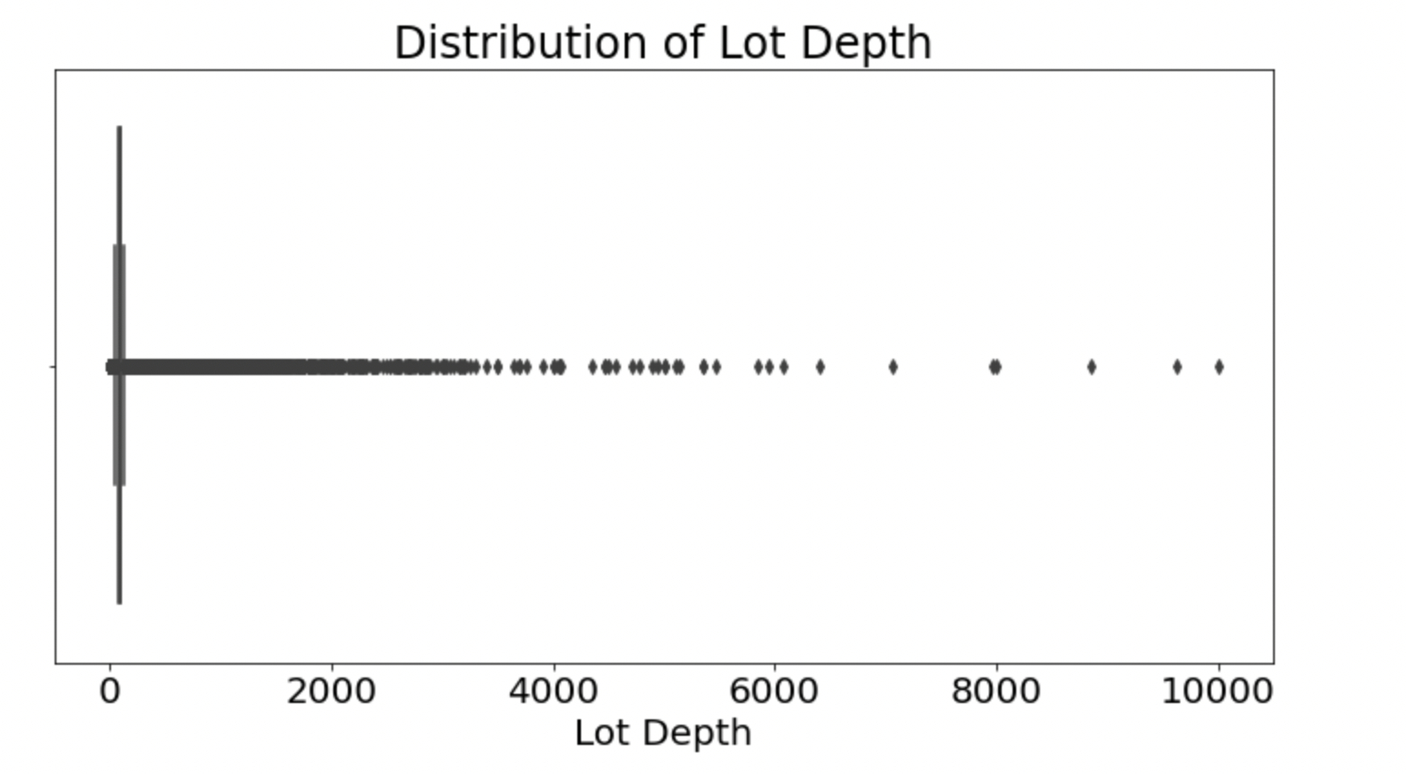

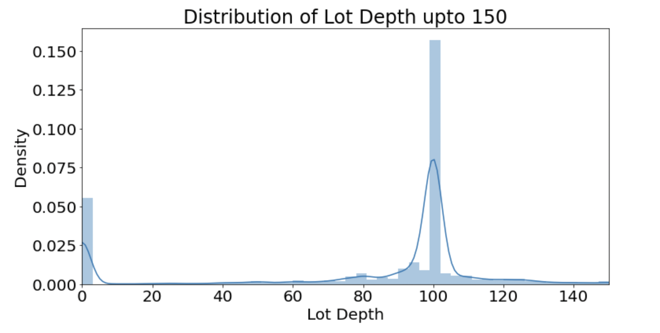

EXT

Column Description: Extension Indicator

Type: Categorical

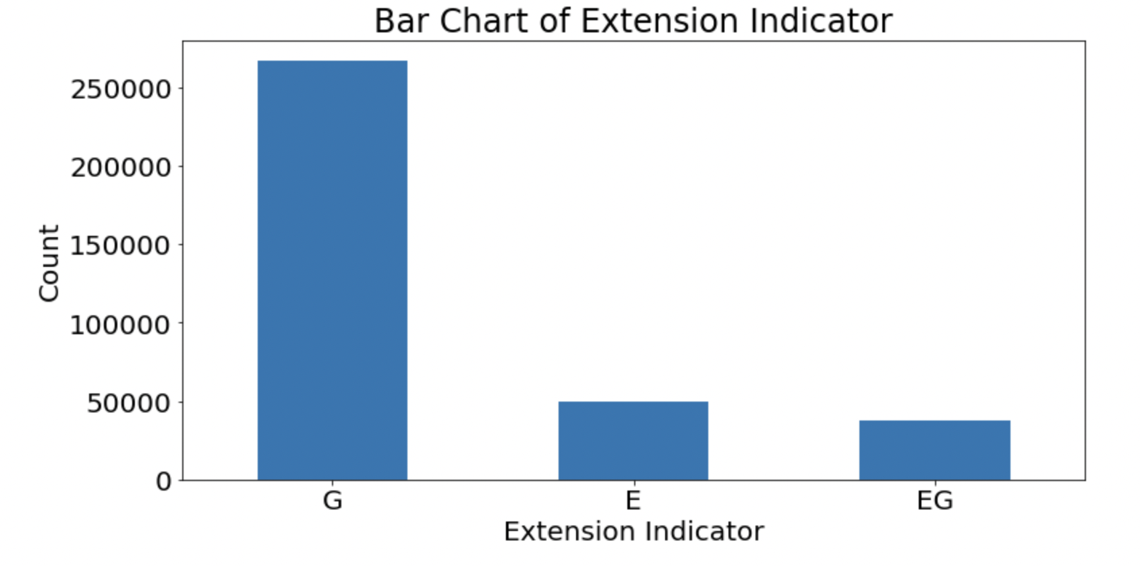

STORIES

Column Description: Indicates number of stories in a building.

Type: Numerical

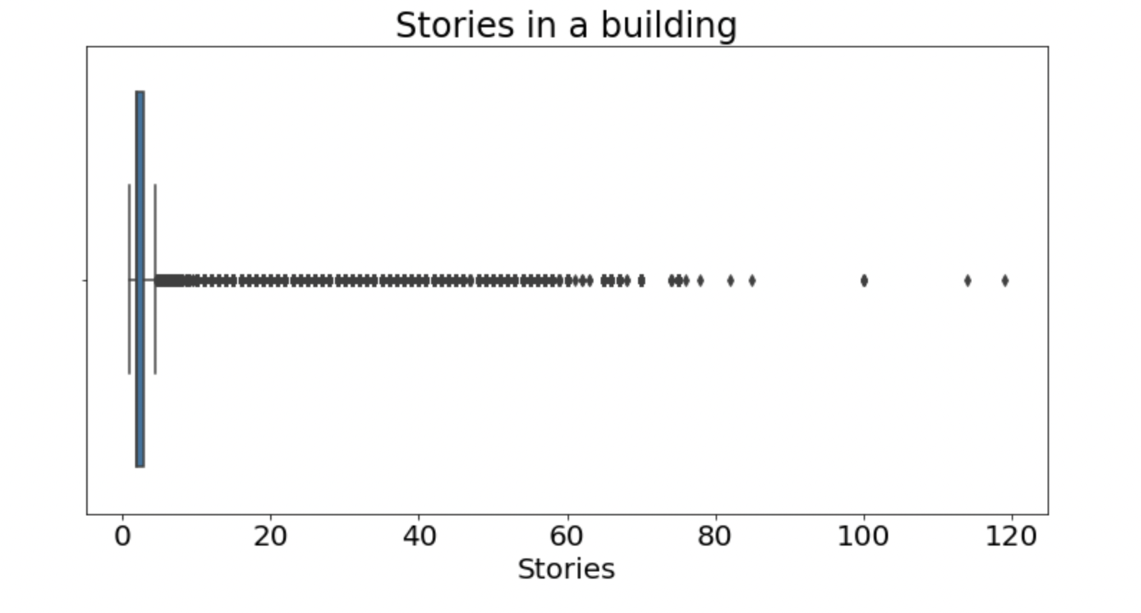

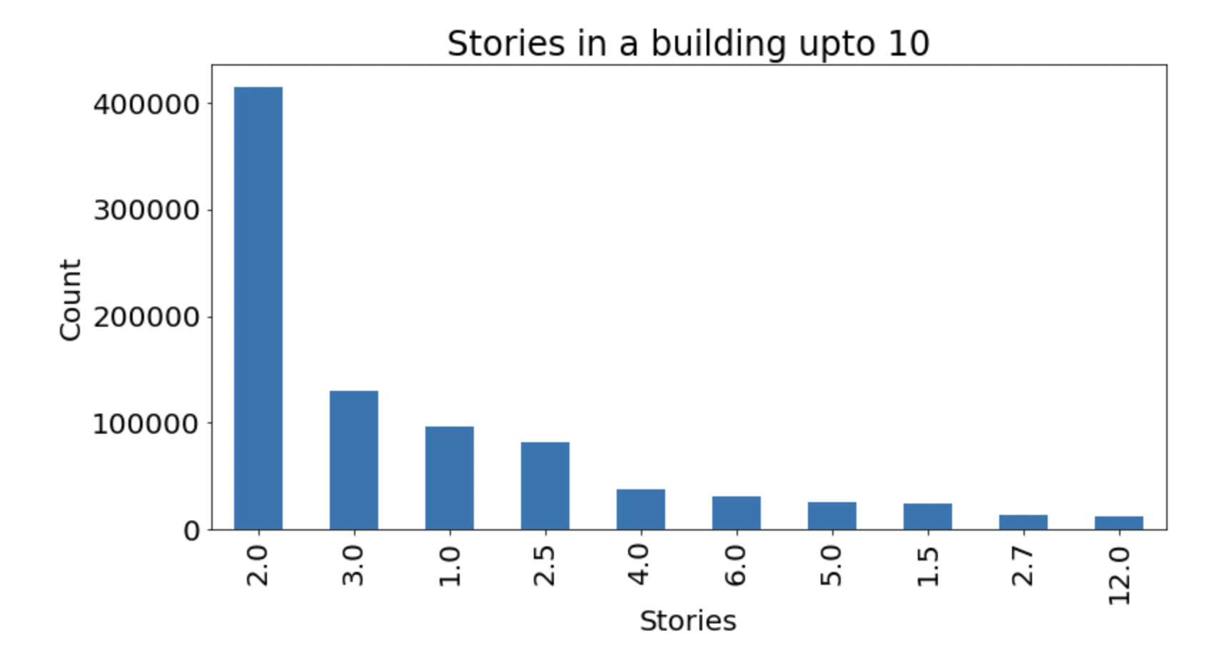

FULLVAL

Column Description: Indicates the market value.

Type: Numerical

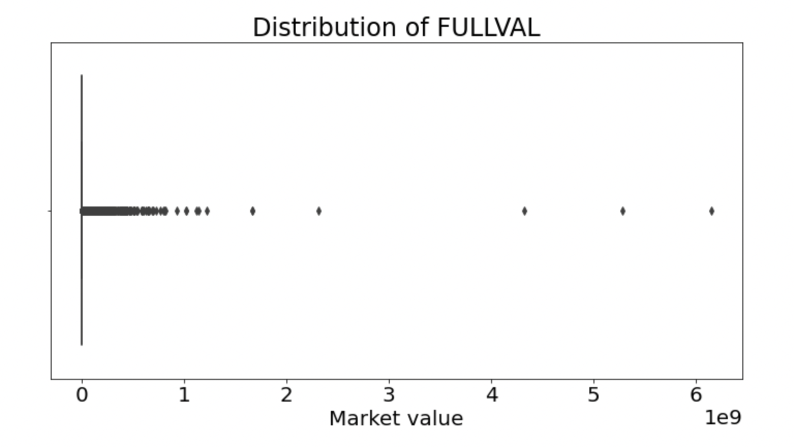

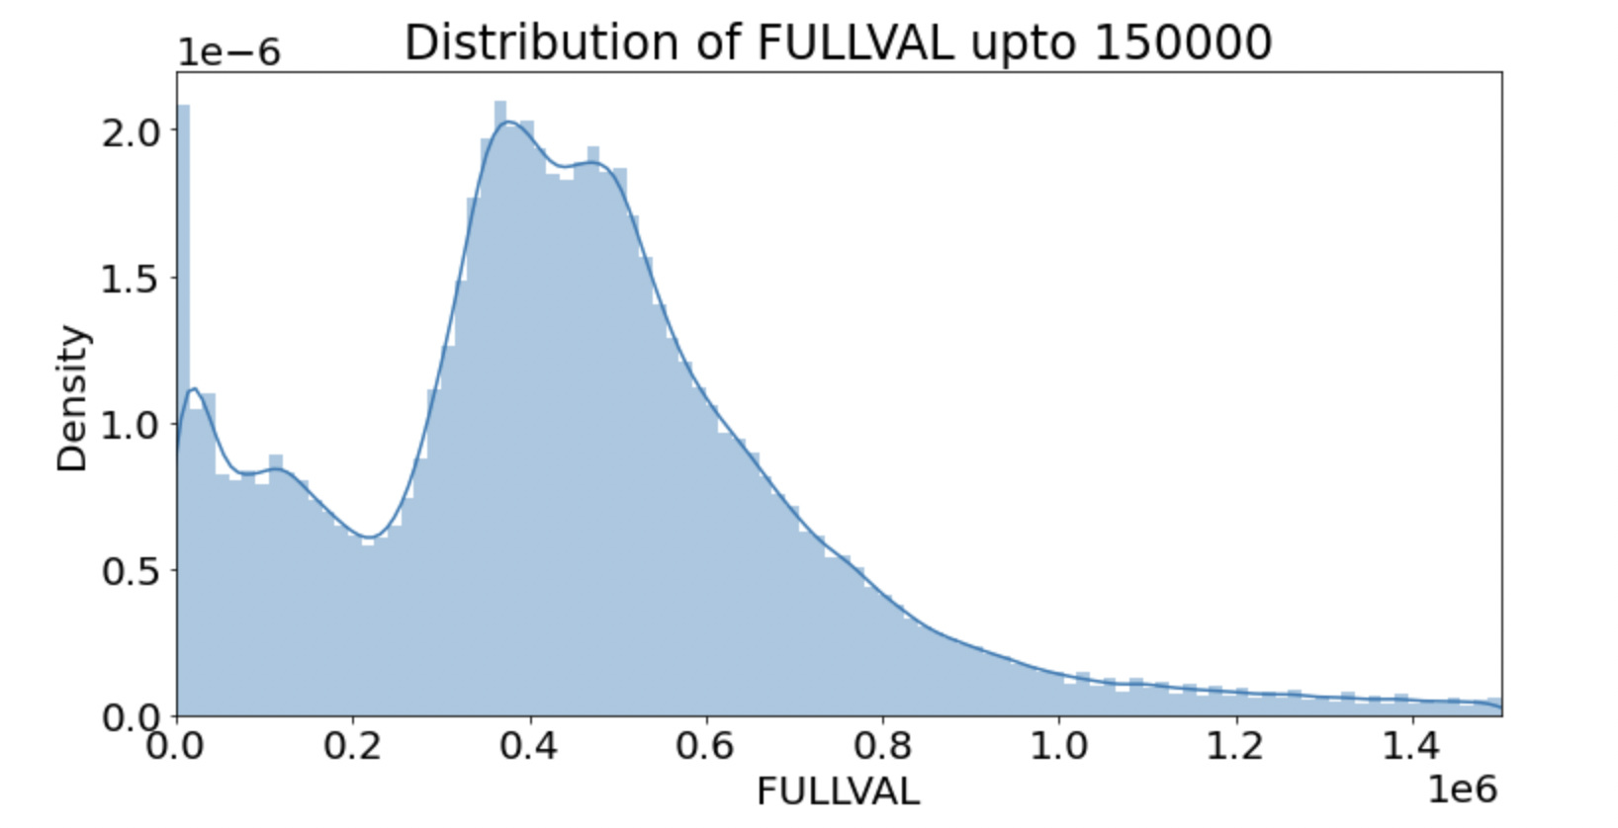

AVLAND

Column Description: Indicates the Actual Total Value.

Type: Numerical

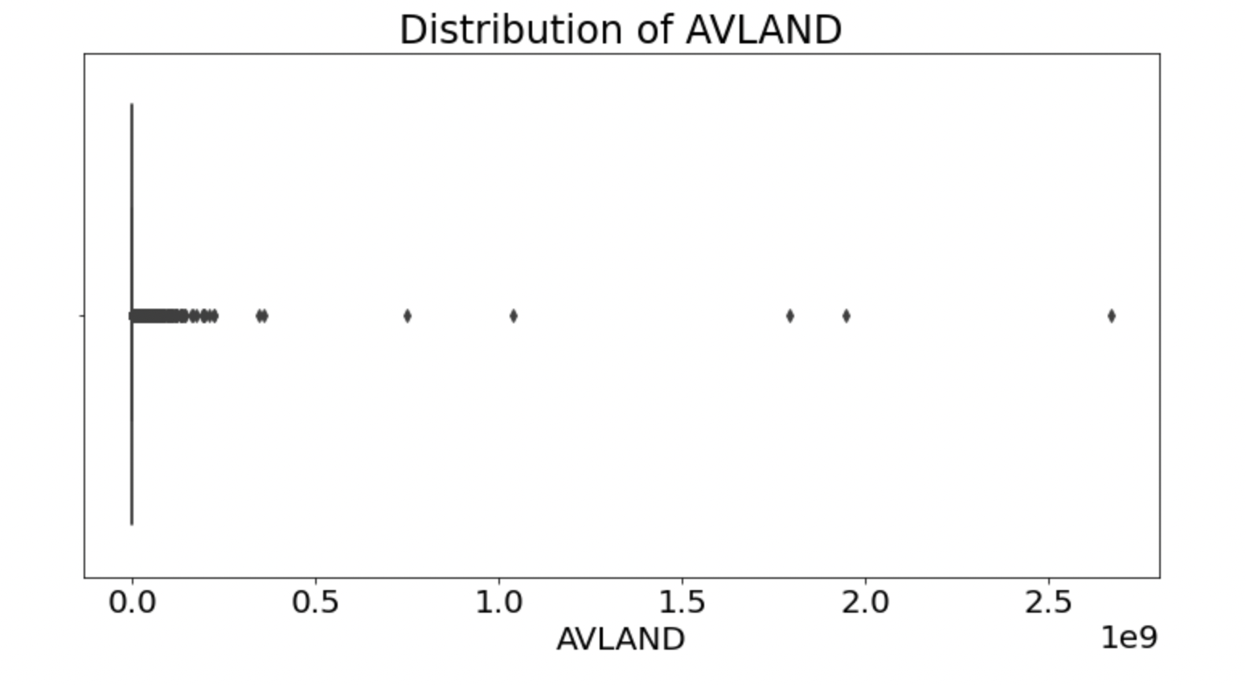

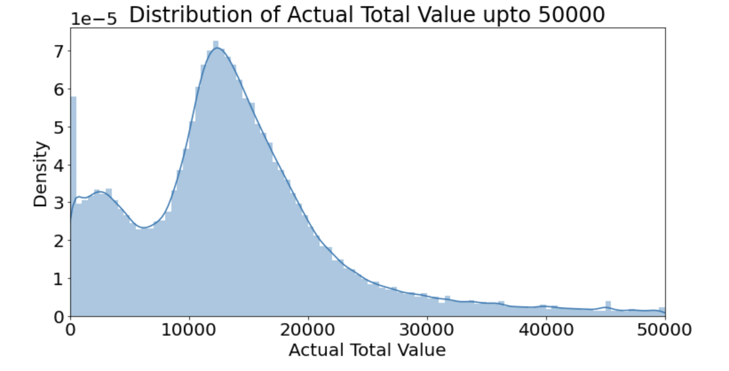

AVTOT

Column Description: Actual total value

Type: Numerical

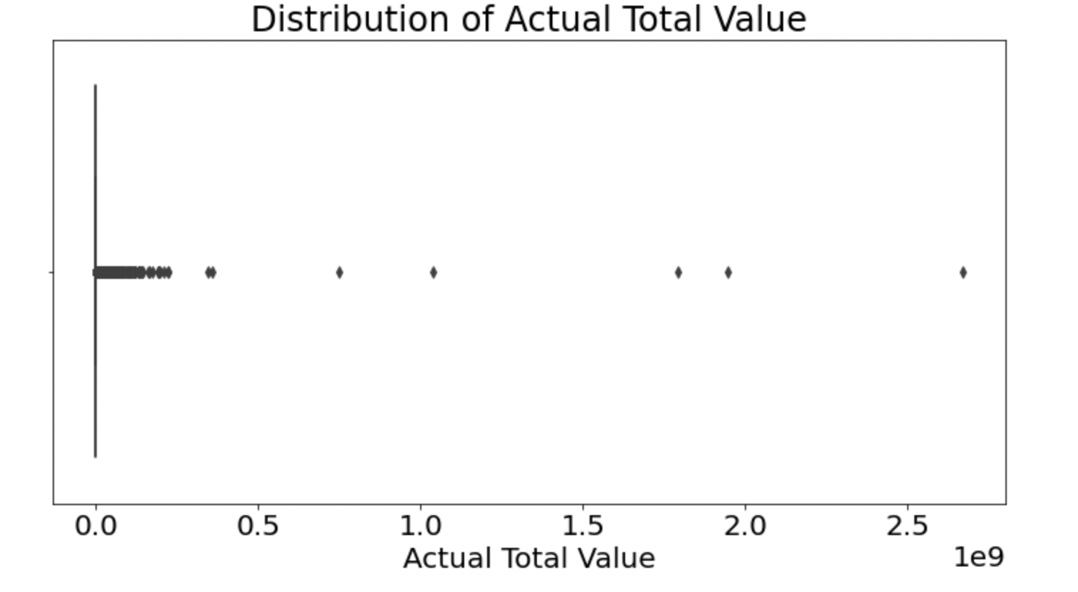

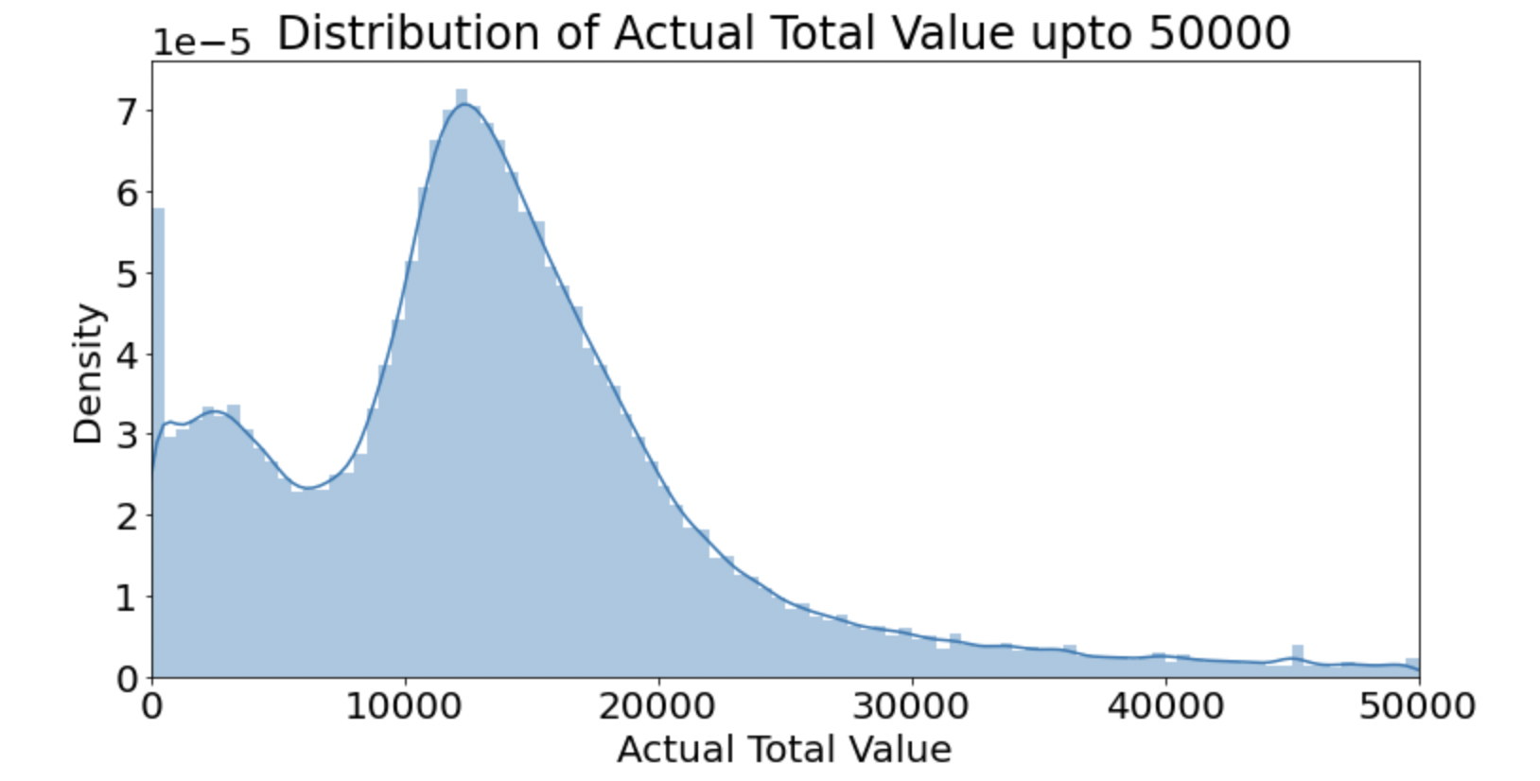

EXLAND

Column Description: Actual Exempt land value

Type: Numerical

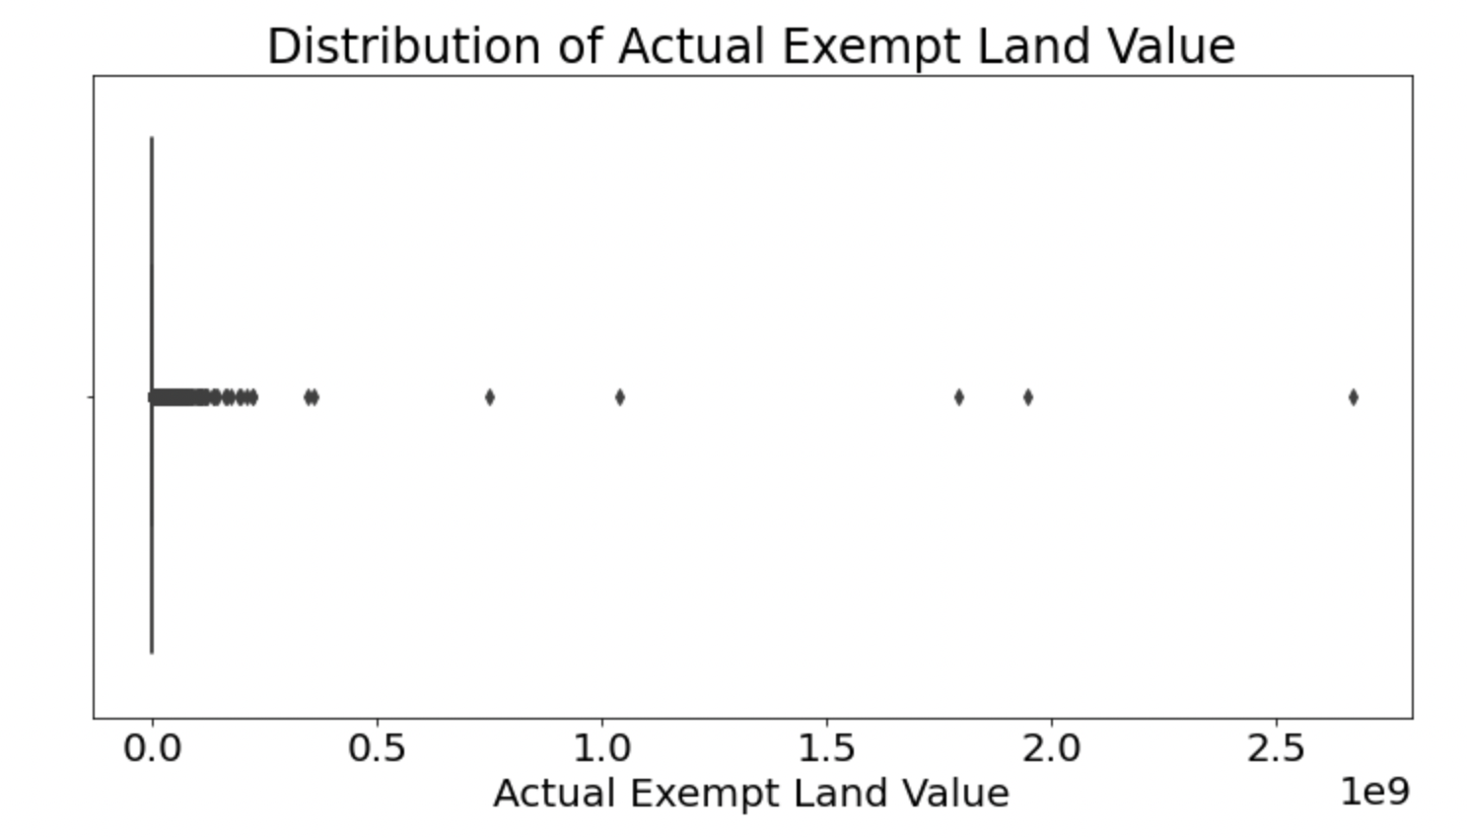

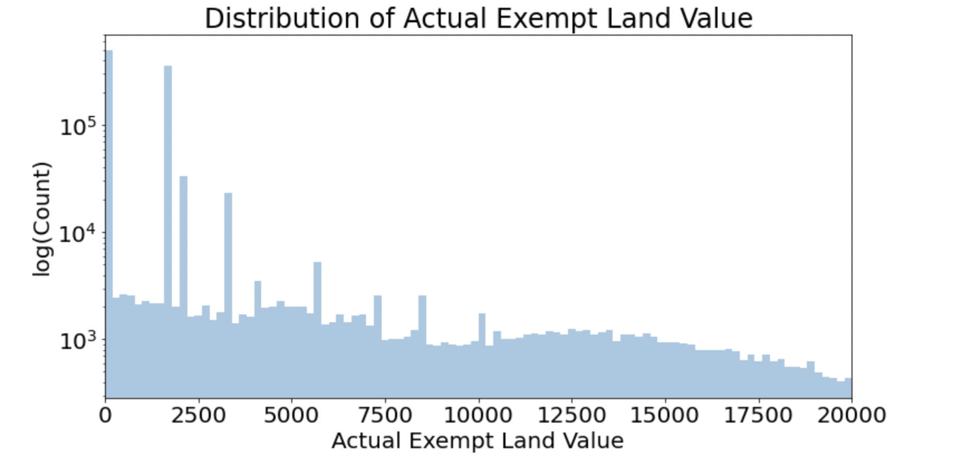

EXTOT

Column Description: Actual exempt land total

Type: Numerical

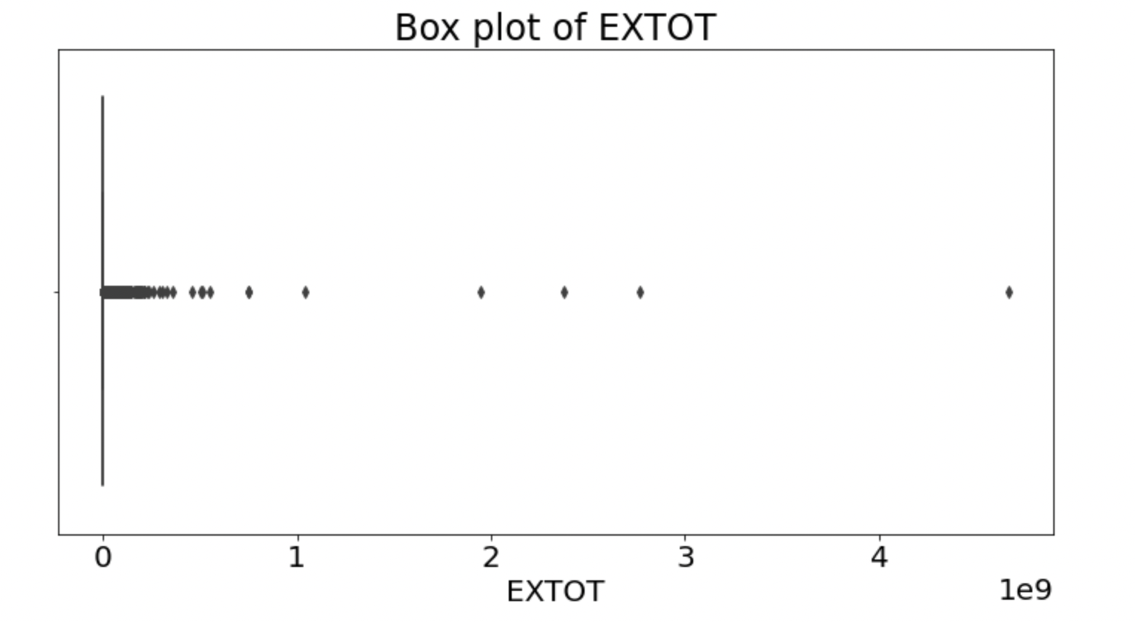

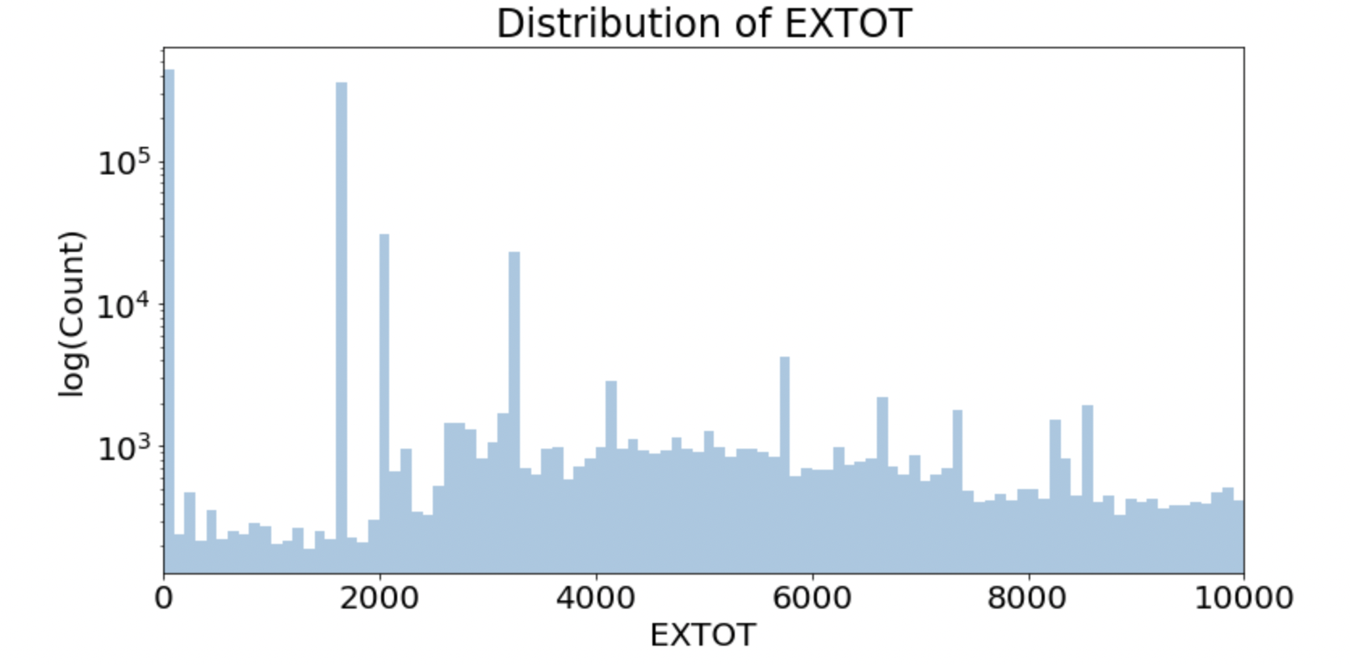

EXCD1

Column Description: Exemption code 1.

Type: Categorical

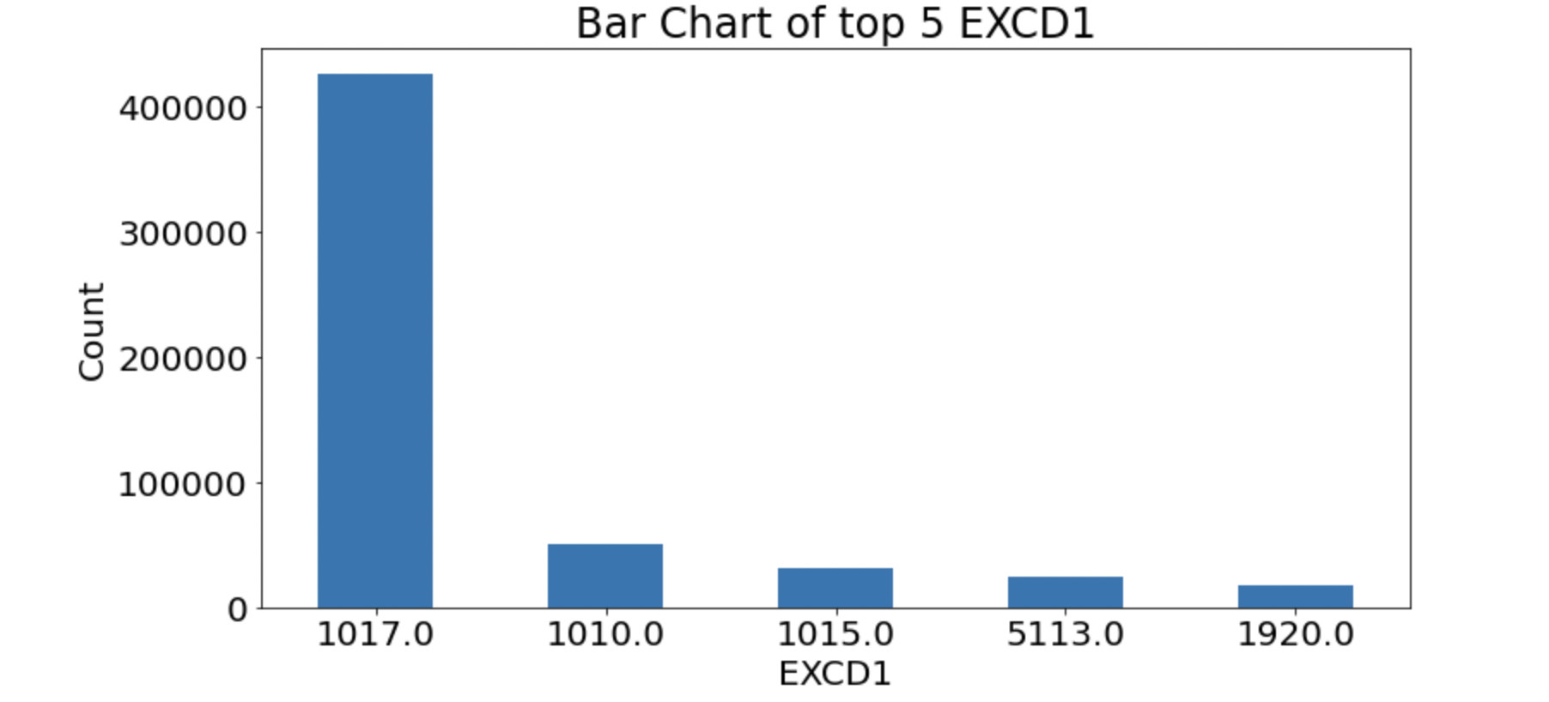

STADDR

Column Description: Street Address.

Type: Categorical

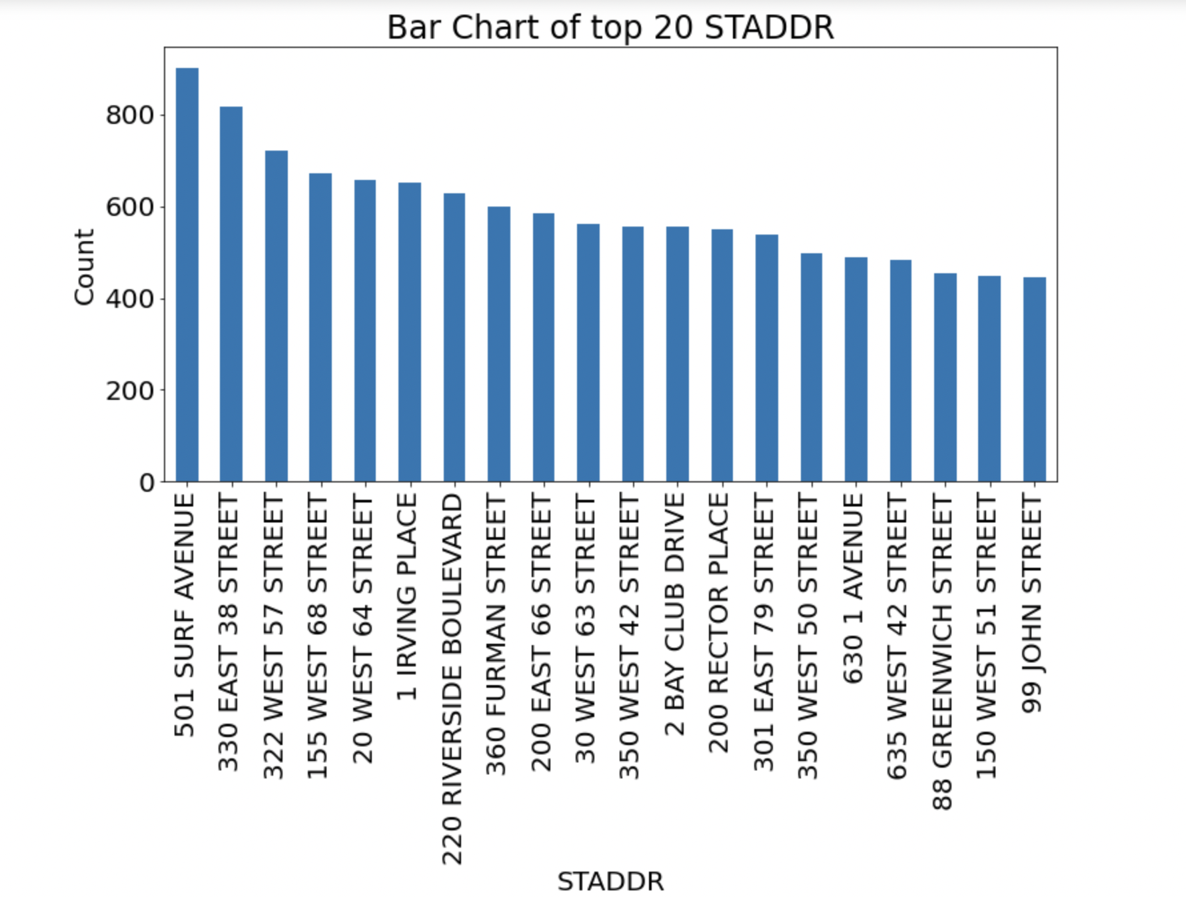

ZIP

Column Description: Zip code of a property.

Type: Categorical

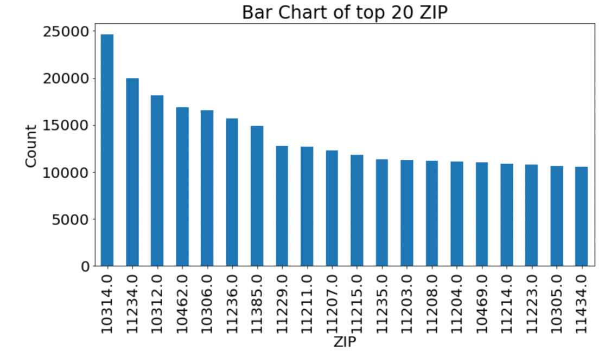

EXMPTCL

Column Description: Exemption Class.

Type: Categorical

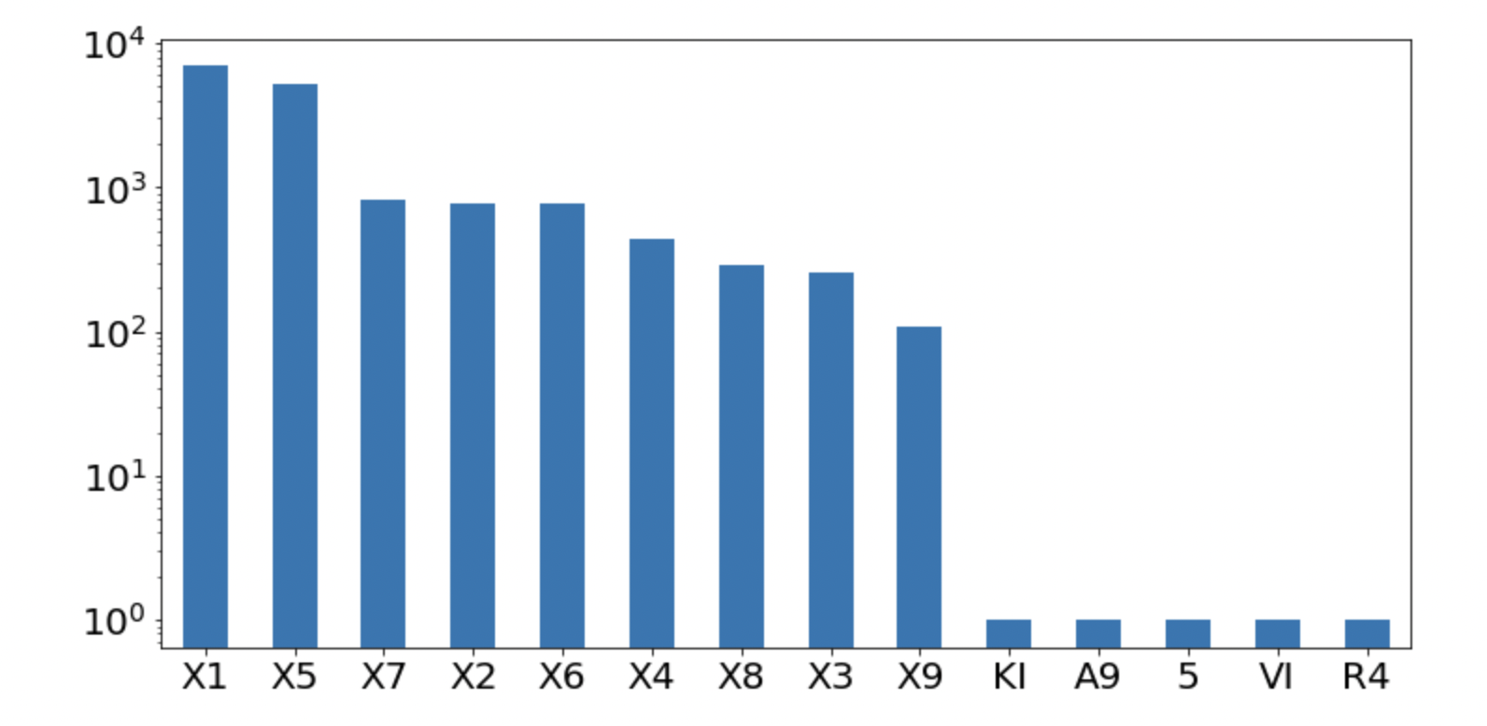

BLDFRONT

Column Description: Building Width.

Type: Numerical

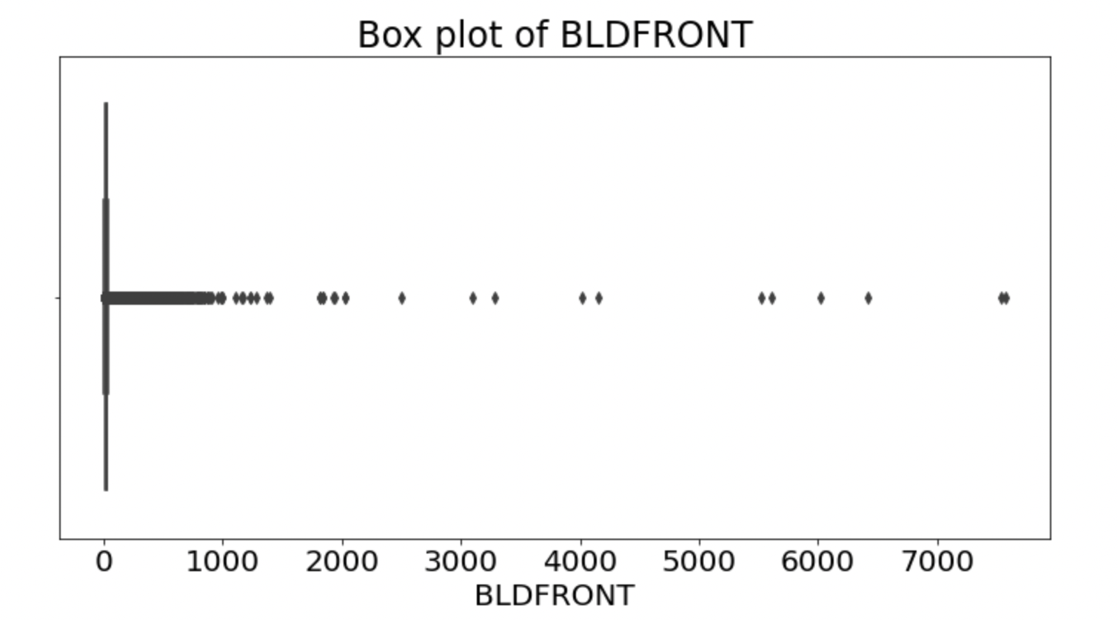

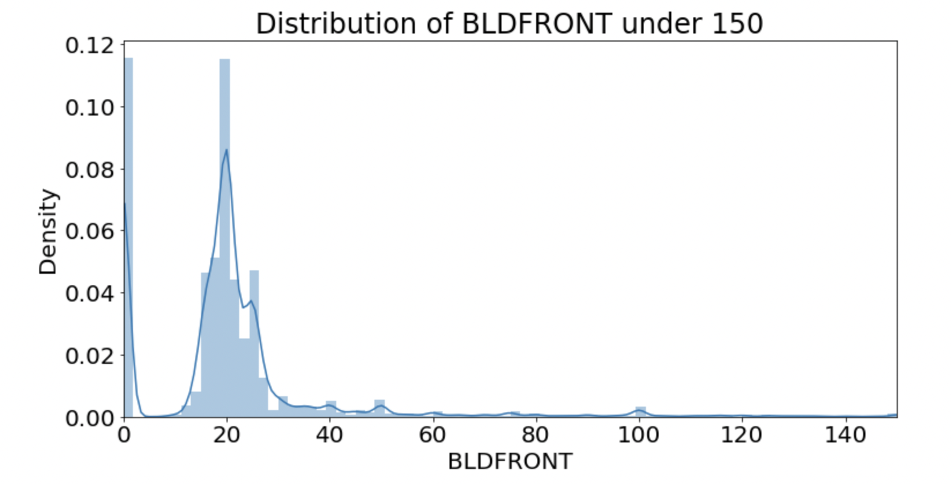

BLDDEPTH

Column Description: Building Depth.

Type: Numerical

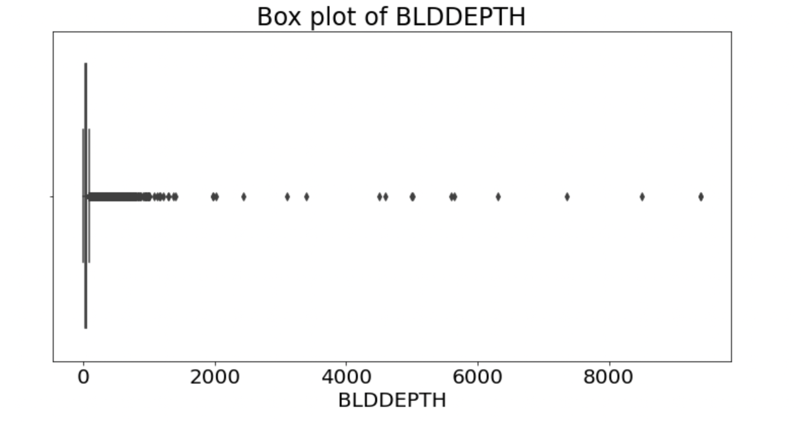

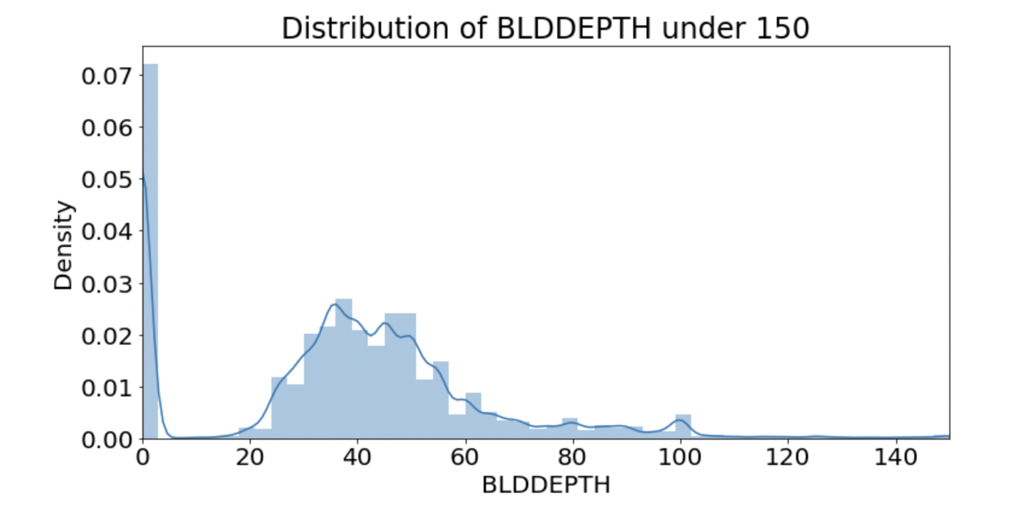

AVLAND2

Column Description: Traditional Land value.

Type: Numerical Value

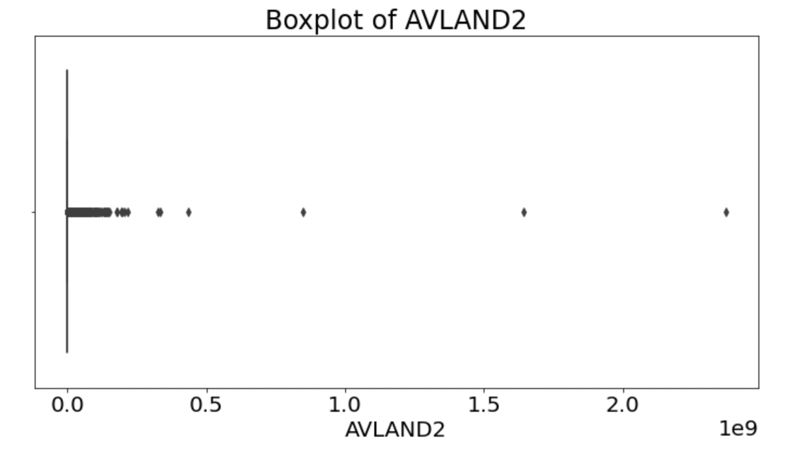

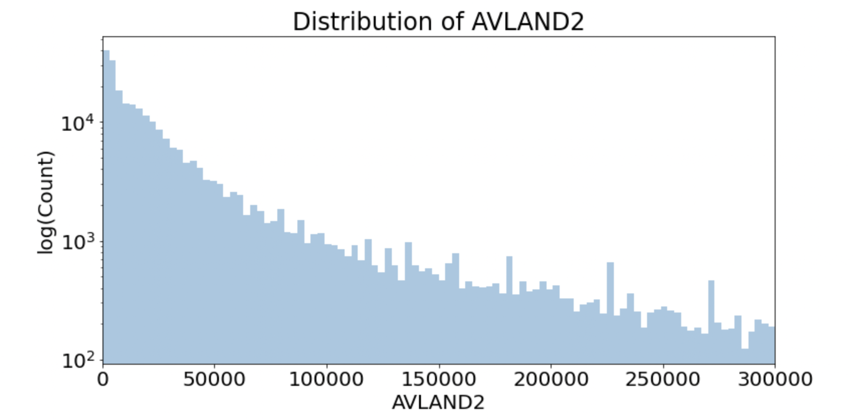

AVTOT2

Column Description: Traditional Total value.

Type: Numerical

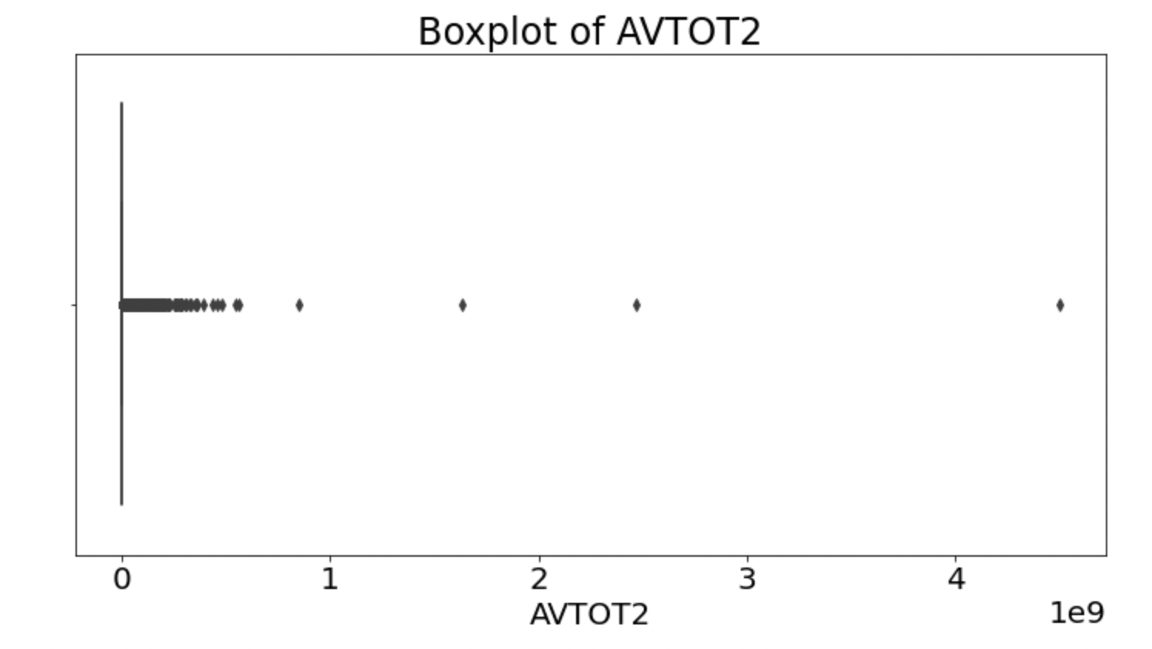

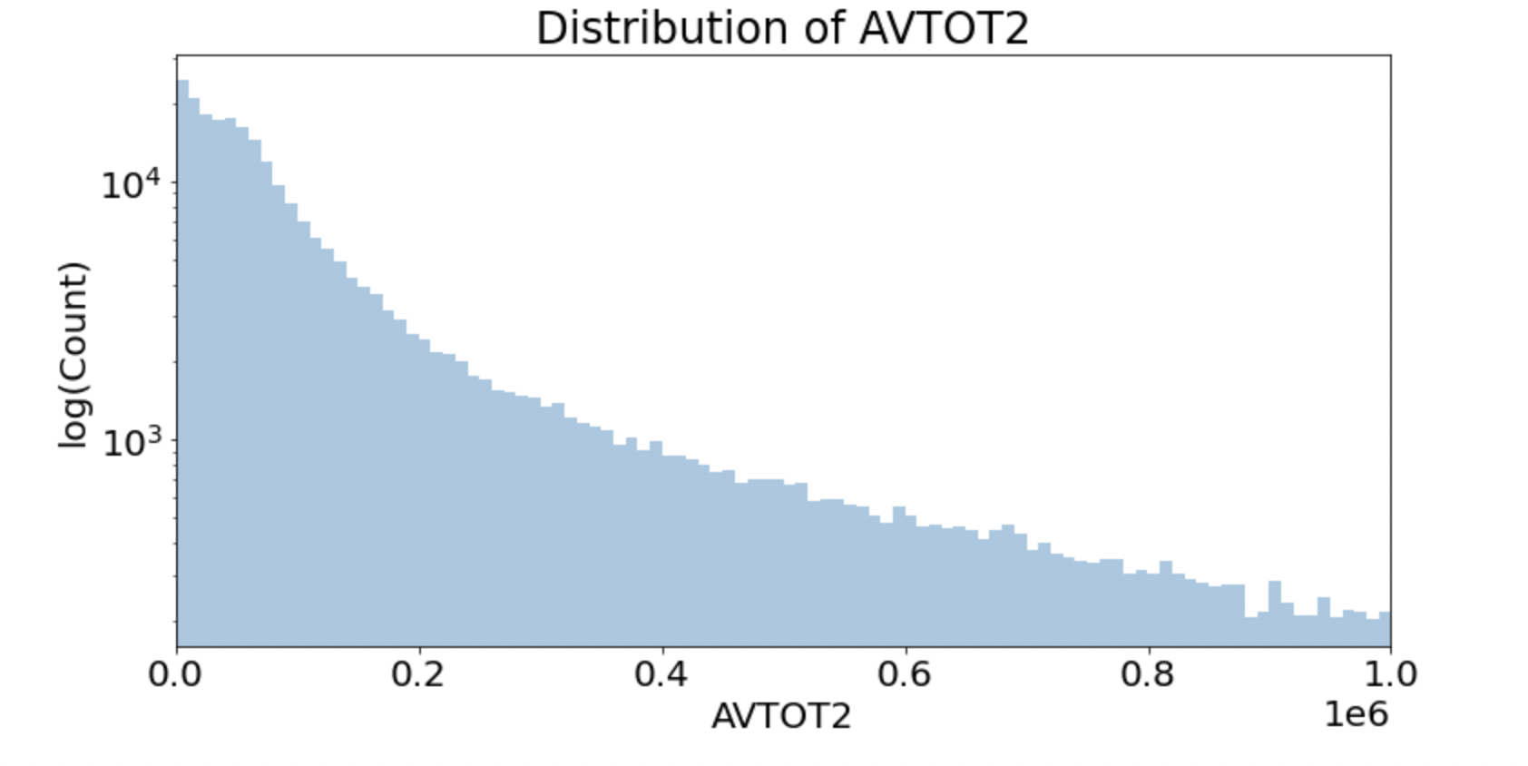

EXLAND2

Column Description: Traditional Exemption Land value.

Type: Numerical

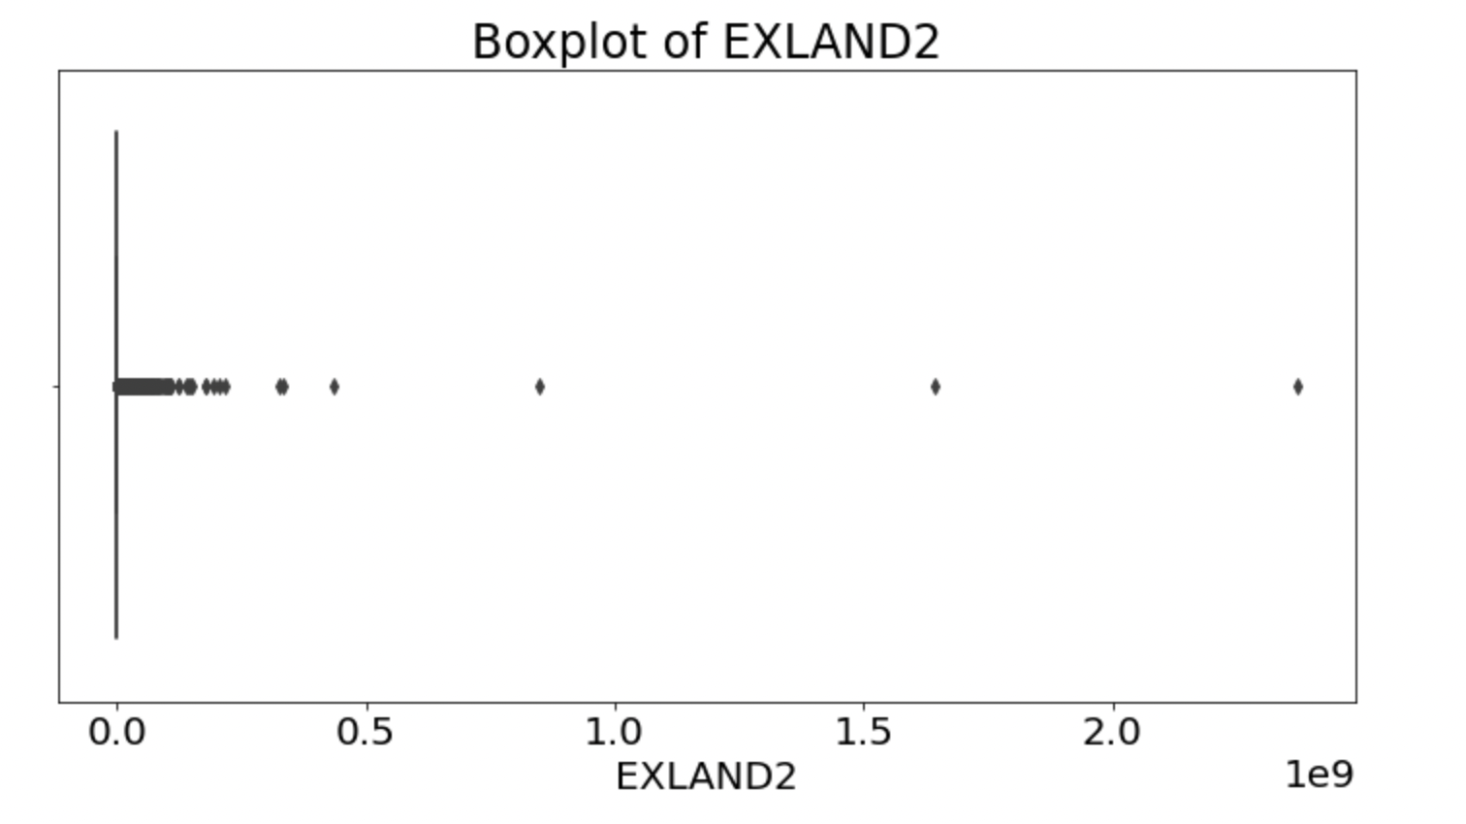

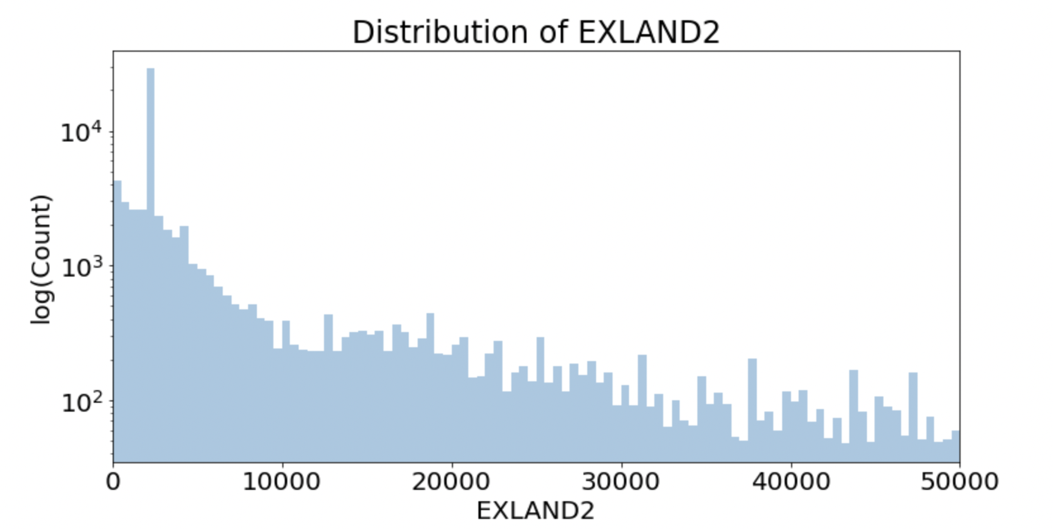

EXTOT2

Column Description: Traditional Exemption Land Total.

Type: Numerical

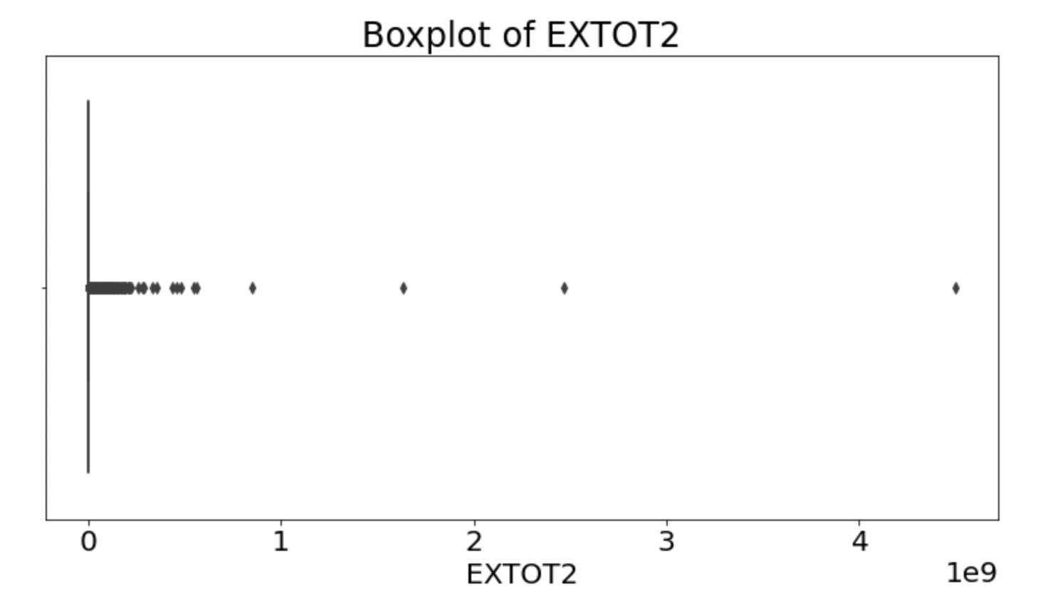 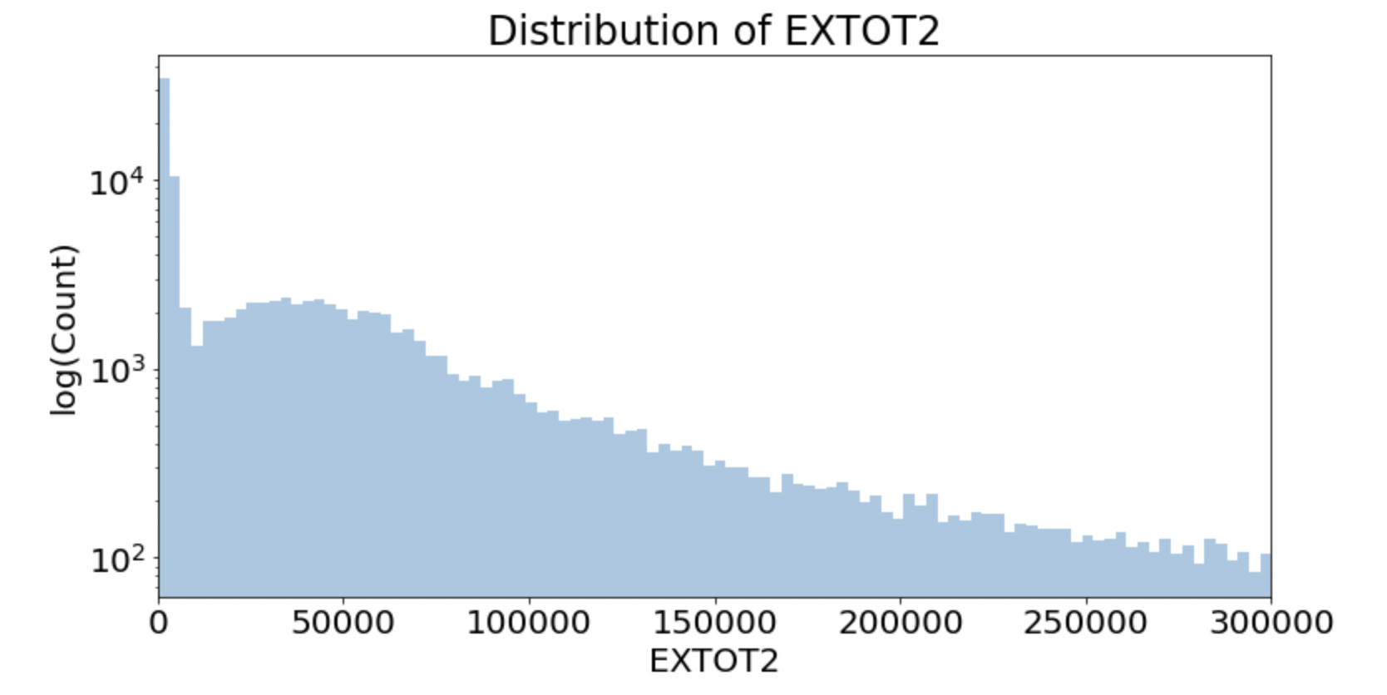

EXCD2

Column Description: Exemption Code 2.

Type: Categorical

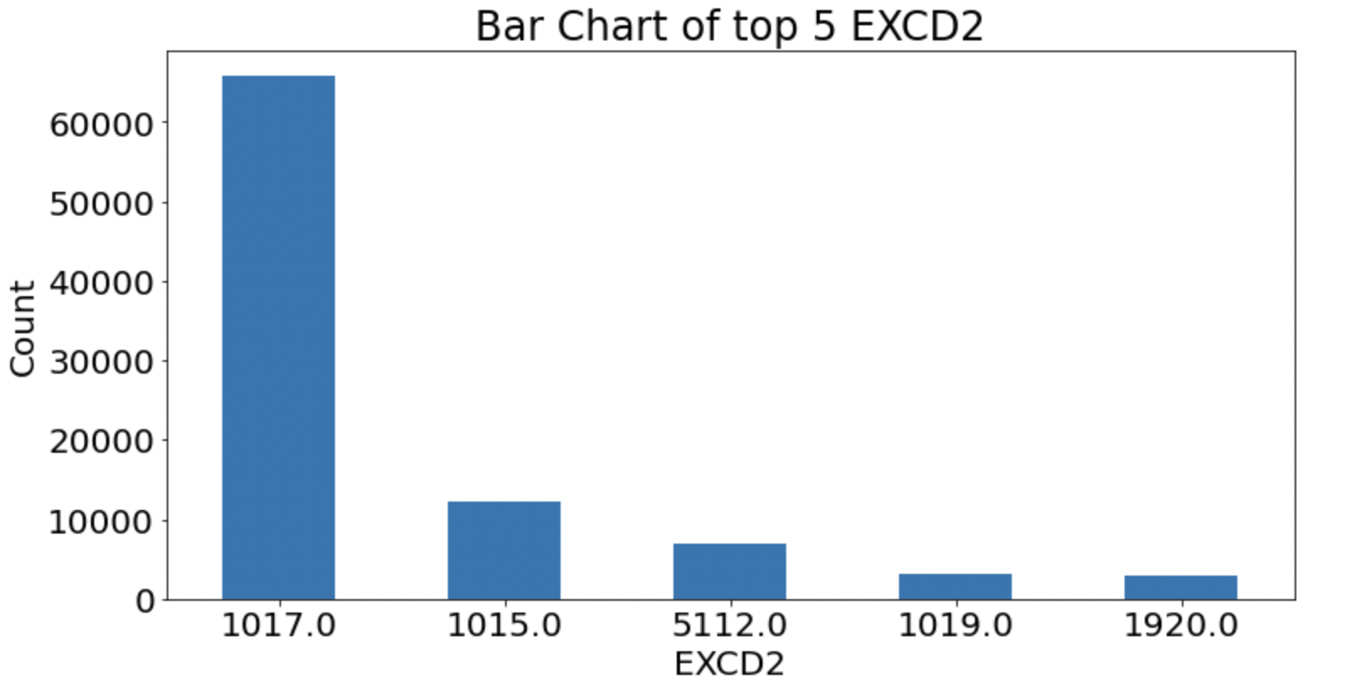

PERIOD

Column Description: Assessment Period when the data was created.

Type: Categorical

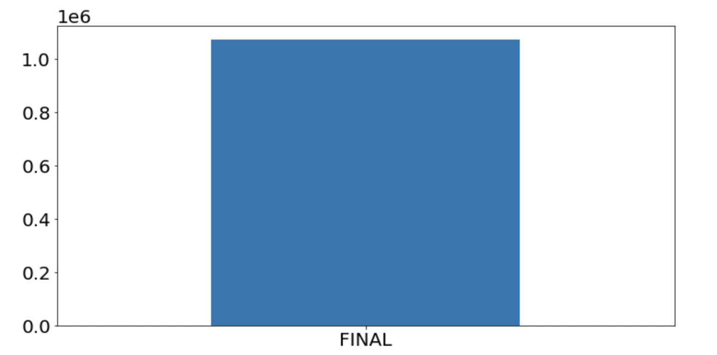

YEAR

Column Description: Assessment Year.

Type: Categorical

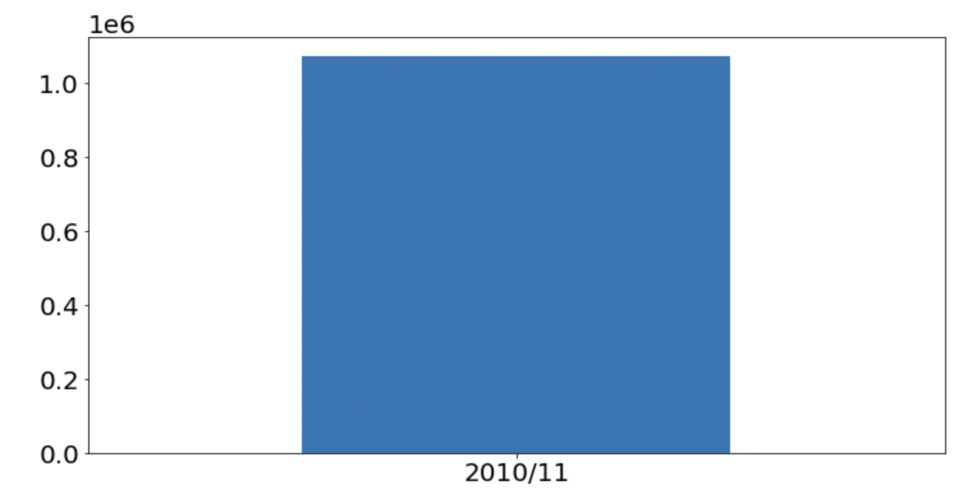

VALTYPE

Type: Categorical Field.

No missing values

